Exploring Physics Set 14

Again, many of these are my suggested answers so if you don’t agree with them then change them before showing them to your students. I will correct them once STAWA makes the answers available.

1. a. A magnetic field is defined as the area surrounding a magnet where a magnetic material (e.g. iron, nickel, cobalt) experiences a magnetic force of attraction.

b.
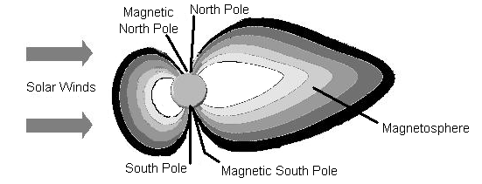

- iron – can be permanent and much stronger due to alignment of domains which stay aligned
doesn’t need an electric current to maintain it, one end will be North and other South so field will be from ends
copper – only occurs when current running through it, very weak, circular around wire rather than from end to end (90⁰ to iron), no north or south end.

- If you create a loops with the copper wire, this will result in a much stronger field within the loops e.g. solenoid and create a north and south end.

2. a. b.

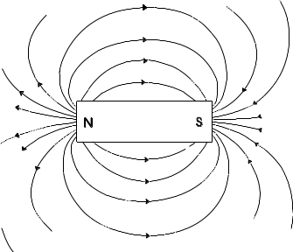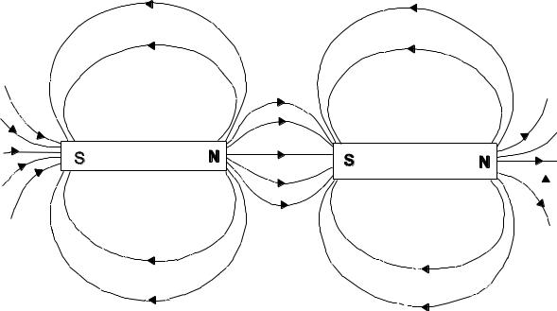

c. d.

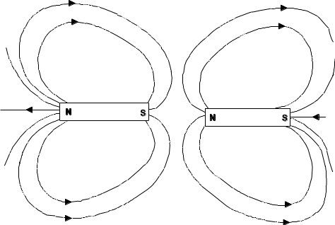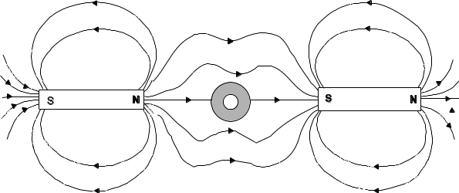

3. a. b.
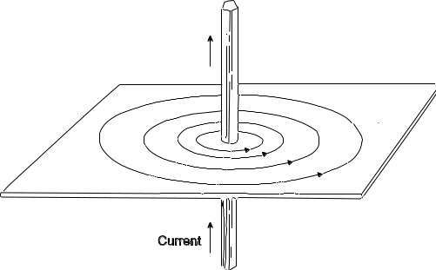 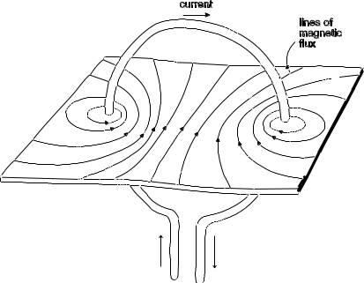OR
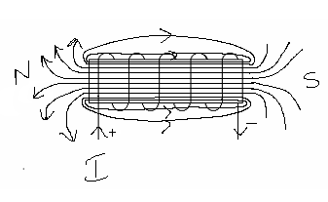

4. a. If parallel to the electron then no effect on electron
b. When perpendicular, electron will experience a force at right angles so will start to follow a curved path.

5. A has a positive charge
B has no charge
C has a negative charge

Remember, using right hand, fingers point direction of field (into page in this case), thumb points direction of charge, palm points force on positive charge and back of hand direction of force on negative charge.

6. a. F = Bvq

- F_{c} = F_{e}
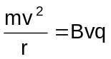
r = 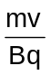
circular path due to F acting at right angles to motion of electron as explained in Q.5.

c. f = 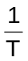 v = 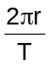
T = 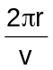
f = 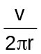

d. Not sure about my answer to this question.
v = 2πrf (assuming you know ‘r’)

B = 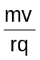

7. q = 1.60 x 10⁻¹⁹ C F_{e} = Bvq
v = 5.0 x 10⁶ m s⁻¹ = 10 x 5.0 x 10⁶ x 1.60 x 10⁻¹⁹
B = 10.0 T = 8.0 x 10⁻¹² N

r₁ = 0.099 ÷ 2 = 0.0495 m F_{e} = F_{c}
r₂ = 0.101 ÷ 2 = 0.0505 m = 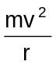
m = 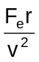
m₁ = 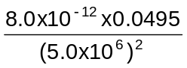 = 1.58 x 10⁻²⁶ kg
m₂ = 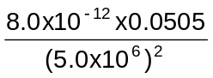 = 1.62 x 10⁻²⁶ kg

so range from 1.58 x 10⁻²⁶ kg to 1.62 x 10⁻²⁶ kg

8.
b. 6.28 ms

- v = 1.00 x 10⁴ m s⁻¹ r = 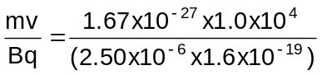
m = 1.67 x 10⁻²⁷ kg r = 41.75
B = 2.50 x 10⁻⁶ T
q = 1.6 x 10⁻¹⁹ C r = 41.8 m

- T = 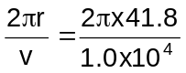
= 0.0263 s
= 2.63 x 10⁻² s

- ‘r’ equals . If strength increases then ‘r’ decreases.
T = so decrease in r results in a decrease in time.
- T = so if ‘v’ increases time will also decrease.

9. a B1 into the page, B2 out of the page.

b q = 1.6x10-19J
v = 1.5x106ms-1
B = 0.10T

F = q.v.B
= 1.6x10-19 x 1.5x106 x 0.10
F = 2.4x10-14N

c Electrons are deviated more because they are in the field longer i.e. the force acts on them for a longer time.

d The magnetic field strength could be stronger at the top and bottom, and decrease in strength towards the middle. The field direction in the top half would still need to be opposite that in the bottom half.

10. a 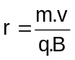

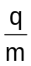 = 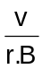

b r1 = 2.9x10-2m
r2 = 3.8x10-2m
v = 2.2x105ms-1
B = 0.12T

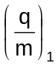 = 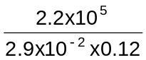
= 6.3x107C.kg-1

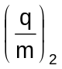 = 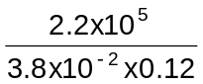
= 4.8x107C.kg-1

c
For 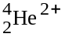 , = 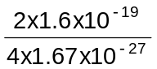
= 4.8x107C.kg-1

For 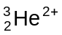 , = 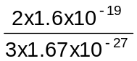
= 6.4x107C.kg-1

The values for the isotopes are close to the experimental values from the mass spectrometer. They are likely to have caused the lines.

d r1 = 62.0x10-3 m
r2 = 66.4x10-3 m
r3 = 70.1x10-3 m
r = 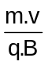
=
= 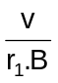
= 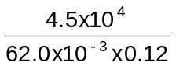
= 6.1x106 C.kg-1

= 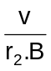
= 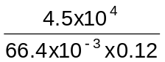
= 5.6x106 C.kg-1

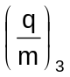 = 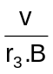
= 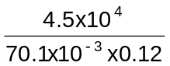
= 5.3x106C.kg-1

m (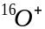) = 2.66x10-26kg
m(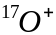) = 2.82x10-26kg
m(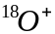) = 2.99x10-26kg
For () , 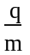 = 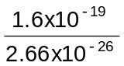
= 6.0x106C.kg-1

For () , = 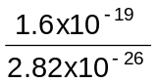
= 5.7x106C.kg-1

For () , = 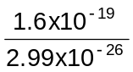
= 5.4x106C.kg-1

Each of the experimental values are within ±0.1 x 106 C.kg-1 of the calculated values for (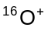) , (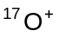) and (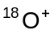) . These three isotopes are possibly the three particles.

